**TEAM MEMBERS:**

Hamza Barg 202322,

Mahatir Hurmat Rai 2023292,

Digital Dice Roller System Design

*This report presents the design and implementation of a Digital Dice Roller system. The project utilizes a 555 timer, 4017-decade counters, 7-segment displays, and logic gates to simulate the rolling of dice. This system offers a compact and electronic alternative to physical dice, providing random numbers (1–6) for gaming or educational applications. The design is cost-effective and reliable, ensuring consistent results for a variety of use cases.*

***Problem Statement***

*Traditional dice are prone to wear and tear, biases, and inaccuracies in certain scenarios. A digital alternative provides a reliable and fair solution for generating random numbers, especially in gaming, educational, and experimental contexts.*

***Objectives***

*Design a system to emulate the rolling of a traditional dice digitally. Ensure fairness and randomness in the results. Provide a cost-effective and user-friendly solution for educational and gaming purposes. Utilize standard digital and analog components to simplify implementation.*

# **Introduction**

*The Digital Dice Roller is a simple, yet effective electronic system designed to emulate the function of traditional dice. By combining fundamental electronic components such as a clock generator, a decade counter, and display drivers, this system generates a random number between 1 and 6 each time the user presses a button. The use of integrated circuits simplifies the design while ensuring accuracy and randomness in the output. This project provides a hands-on application of digital electronics principles and demonstrates how common components can be used to create practical systems.*

# ***Schematic Design***

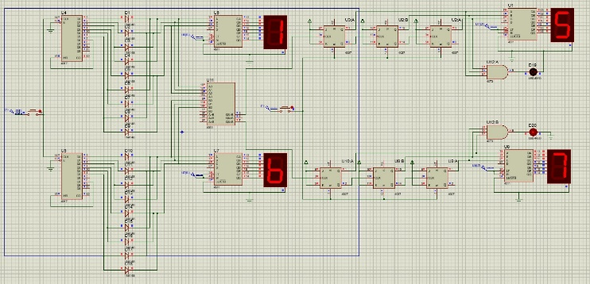

Figure 1

The schematic diagram explains the interaction of the 555 timer, decade counter, logic gates, and 7-segment display to generate and display random numbers between 1 and 6.

**2.1. System Overview**

*The design of the Digital Dice Roller is centred around a systematic combination of various digital and analogy components to achieve randomness and display results accurately. Each section of the system plays a critical role in ensuring proper operation. Below is a detailed breakdown of the key components and their functionalities.*

**2.2. 555 Timer:**

* *Configured in astable mode to generate continuous clock pulses.*
* *The pulse frequency determines the speed at which the dice "rolls" before settling on a number.*

**2.3. CD4017 Decade Counter:**

* *A 10-output counter that sequentially activates its outputs based on clock pulses.*
* *Outputs corresponding to numbers greater than 6 are suppressed using logic gates.*

2.4. **Logic Gates:**

* *AND and OR gates are used to filter and reset the counter when outputs exceed the desired range.*
* *Ensures that only numbers 1 to 6 are displayed.*

**2.5. 4511 Display Driver:**

* *Converts binary inputs into a format compatible with 7-segment displays.*
* *Simplifies the connection between the counter and the display.*

**2.6. 7-Segment Display:**

* *Provides a clear and readable visual representation of the dice roll outcome.*

**2.7. Push Button:**

* *Allow user interaction to trigger the dice roll.*
* *Introduces variability by starting and stopping the clock pulses at random intervals.*

# **Methodology**

* + 1. ***Clock Pulse Generation***

The 555 timer acts as the heart of the system, generating clock pulses at a stable frequency. These pulses are fed into the CD4017 decade counter, which uses them to cycle through its outputs.

* 1. ***Counting and Decoding***

*The CD4017 decade counter activates one output at a time in a sequential manner. Since a standard dice has only six faces, logic gates are used to reset the counter when outputs corresponding to numbers greater than 6 are activated. This ensures that the displayed numbers are always within the valid range****.***

* 1. ***Display Conversion***

*The binary outputs from the counter are processed by the 4511-display driver, which translates the data into signals suitable for driving a 7-segment display. This step simplifies the visualization of the dice roll outcome.*

* 1. ***Random Output Generation***

*The push button adds an element of randomness to the system. By controlling when the clock pulses start and stop, the user can introduce variability into the dice roll, ensuring fair and unpredictable results.*

# **Flow Chart**

1. *Start*
2. *Generate clock pulses using the 555 timers.*
3. *Sequentially activate outputs with the CD4017 counter.*
4. *Filter invalid outputs using logic gates.*
5. *Display valid outputs (1–6) on the 7-segment display.*
6. *Wait for the next button press.*
7. *Repeat****.***

# ***Results And Discussion***

1. ***Results***

*The Digital Dice Roller system was successfully implemented and tested. The system consistently generated random numbers between 1 and 6, with results displayed accurately on the 7-segment display. Repeated trials confirmed the reliability and precision of the design.*

1. **Discussion**

*This design demonstrates the practical application of basic digital components in creating a functional system. The use of logic gates ensures that only valid outputs are displayed, while the 4511 driver simplifies the interface between the counter and the display. Potential improvements include adding features such as:*

* *Rolling multiple dice simultaneously.*
* *Implementing an automatic rolling feature.*
* *Enhancing the display to show additional information, such as the sum of multiple rolls*.

# **Conclusion**

*The Digital Dice Roller system provides a reliable and efficient alternative to traditional dice. By leveraging basic electronic components, the system ensures fair and random results, making it ideal for gaming, educational, and demonstration purposes. Future enhancements could expand the system's functionality, increasing its versatility and appeal. This project highlights the importance of integrating digital components and showcases their potential for creating innovative and practical solutions.*

# **Acknowledgement**

*We from the bottom of our heart thank Ma’am Samina Yasmin and the Faculty of Electrical Engineering - GIK Institute for making this project come true and always standing behind us at every point of this project.*

# ***References***

1. ***Sedra, A. S., & Smith, K. C. (2015). Microelectronic Circuits. Oxford University Press.***
2. ***Tocci, R. J., Widmer, N. S., & Moss, G. L. (2011). Digital Systems: Principles and Applications. Pearson.***
3. ***Manufacturer Datasheets for 555 Timer, CD4017, and 4511 ICs.***